Major ALEXANDER J. “AJ” SHIN
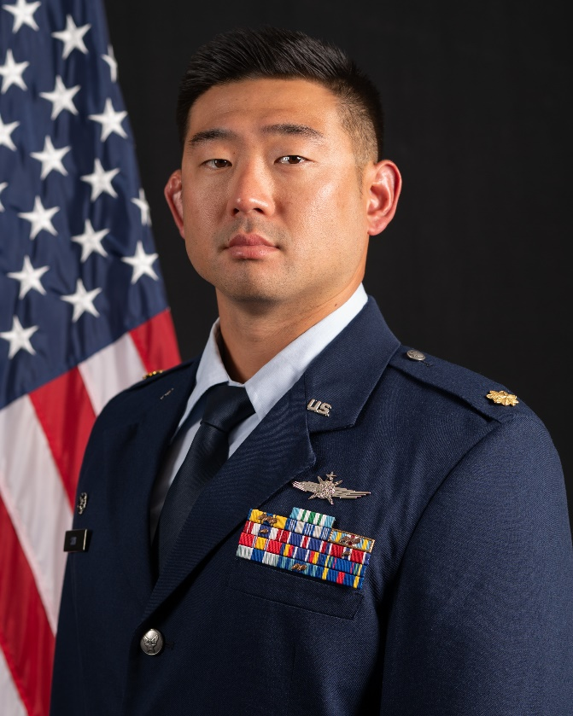
Maj Alexander J. Shin is the Commander of the 644th Combat Communications Squadron, Northwest Field, Andersen AFB, Guam. He is directly responsible for 120 Airmen with 17 Air Force Specialty Codes to provide secure and non-secure voice and data services in support of USINDOPACOM’s command and control theater Operations, Contingencies, and Humanitarian Assistance and Disaster Relief missions. Maj Shin operates and maintains over $102M of tactical communication equipment for bare base expeditionary deployments across the globe.

Maj Shin received his commission from the U.S. Air Force Academy in May 2010 and completed Undergraduate Cyber Training at Keesler AFB, Mississippi in April 2011. His experience spans from operations in the 36 Contingency Response Group, the 353 Air Force Special Operations Group, 693 Intelligence Surveillance Reconnaissance Group, Joint Special Operations Command, U.S. Special Operations Command, and Special Operations Command Pacific.

Prior to his current position, Major Shin was a student at Air Command and Staff College where he earned his Masters in Military Operational Art and Science, as well as co-authored literature in support of the Taiwan Deterrence Research Task Force, sponsored by INDOPACOM. His last operational assignment was as the J6 Plans Division Chief in Special Operations Command Pacific, Camp Smith, Hawaii. Major Shin led SOCPAC's contested communications portfolio in support of the #1 priority of the NDS, creating the C4I strategy adopted by INDOPACOM, components, and interagency partners. He also served as the SOCPAC liaison officer to SOCOM for 7 months, reporting directly to the SOCPAC Commander, integrating actions across 9 staff directorates in 24 KLEs. Major Shin was the SME for enabling C4ISR in support of 24 OPLANs/CONPLANs, ensuring SOCPAC's capability to execute mission sets across 36 countries. He was also directly responsible for ensuring SOCPAC's C2 of over 320 SOF Operations, Activities, and Investments with 24/7 support to SOF forces in 13 countries and 5 Theater SOF Command teams.

EDUCATION
2010 Bachelor of Science in Social Sciences, United States Air Force Academy, Colorado Springs, Colorado
2011 Air and Space Basic Course, Maxwell AFB, Alabama
2014 Squadron Officer School, Maxwell AFB, Alabama
2015 Masters of Arts in Management and Leadership, Liberty University, Lynchburg, Virginia
2022 Air Command and Staff College, Maxwell AFB, Alabama, by correspondence
2024 Masters of Military Operational Art and Science, Air Command and Staff College, Maxwell AFB, Alabama

ASSIGNMENTS or CAREER CHRONOLOGY
1. August 2010 – April 2011, Student, Undergraduate Cyberspace Training, 333 TRS, Keesler AFB, Mississippi
2. May 2011 – May 2012, Deputy Flight Commander, RF Transmissions, 644 CBCS, Andersen AFB, Guam
3. June 2012 – April 2013, Deputy Chief of Maintenance, 644 CBCS, Andersen AFB, Guam
4. May 2013 – May 2014, Officer in Charge, Fixed Communications, 353 SOSS, Kadena AB, Okinawa
5. June 2014 – April 2015, Officer in Charge, Tactical Communications, 353 SOSS, Kadena AB, Okinawa
6. May 2015 – May 2016, Executive Officer & Branch Chief, Infrastructure, IMSC Det 5, Ramstein AB, Germany
7. June 2016 – April 2017, Assistant Director of Operations, 693 ISS, Ramstein AB, Germany
8. March 2017 – October 2017, Flight Commander, Operations, 693 ISS, Ramstein AB, Germany
9. September 2017 – September 2018, Deputy Branch Chief, NC3 Systems Integration, NC3 Center, Barksdale AFB, Louisiana
(April 2018 – October 2018, Action Officer, CJ63, Combined Joint Task Force-Operation INHERENT RESOLVE, Camp Arifjan, Kuwait)
10. October 2018 – May 2019, Deputy Branch Chief, NC3 Airborne Systems, NC3 Center, Barksdale AFB, Louisiana
11. June 2019 – September 2019, Branch Chief, Operations Reporting Cell, NC3 Center, Barksdale AFB, Louisiana
12. October 2019 – September 2020, Operations and Plans Officer, J6, JSOC, Fort Liberty, North Carolina
13. October 2020 – September 2021, Branch Chief, Future Operations, J6, JSOC, Fort Liberty, North Carolina
(May 2021 – August 2021, J6 Director, Joint Task Force-Operation INHERENT RESOLVE)
14. October 2021 – September 2022, Division Chief, Directorate Support, J6, SOCPAC, Camp Smith, Hawaii
(April 2022 – October 2022, SOCPAC Liaison Officer, SOCOM, MacDill AFB, Florida)
15. October 2022 – June 2023, Division Chief, Plans, J6, SOCPAC, Camp Smith, Hawaii
16. July 2023 – June 2024, Student, Air Command and Staff College, Maxwell AFB, Alabama
17. July 2024 – Present, Commander, 644 CBCS, Northwest Field, Andersen AFB, Guam

SUMMARY OF JOINT ASSIGNMENTS
- October 2019 – September 2020, Operations and Plans Officer, J6, JSOC, Fort Liberty, North Carolina, as a Major
- October 2020 – September 2021, Branch Chief, Future Operations, J6, JSOC, Fort Liberty, North Carolina, as a Major
(May 2021 – August 2021, J6 Director, Joint Task Force-Operation INHERENT RESOLVE)
- October 2021 – September 2022, Division Chief, Directorate Support, J6, SOCPAC, Camp Smith, Hawaii, as a Major
(April 2022 – October 2022, SOCPAC Liaison Officer, SOCOM, MacDill AFB, Florida)
- October 2022 – June 2023, Division Chief, Plans, J6, SOCPAC, Camp Smith, Hawaii, as a Major

MAJOR AWARDS AND DECORATIONS
Joint Service Commendation Medal with 3 oak leaf clusters
Air and Space Commendation Medal with 3 oak leaf clusters
Air and Space Achievement Medal
Global War on Terrorism Medal
National Defense Service Medal

PUBLICATIONS
(PENDING) “Taiwan Civil Guard,” Air University, Maxwell Air Force Base, Alabama, 2024

EFFECTIVE DATES OF PROMOTION
Second Lieutenant May 26, 2010
First Lieutenant May 26, 2012
Captain May 26, 2014
Major March 1, 2020

(Current as of August 2024)

