5

|  |  |  |
| --- | --- | --- |
| Seal | Biography | Flag |
| ***UNITED STATES AIR FORCE*** | | | |

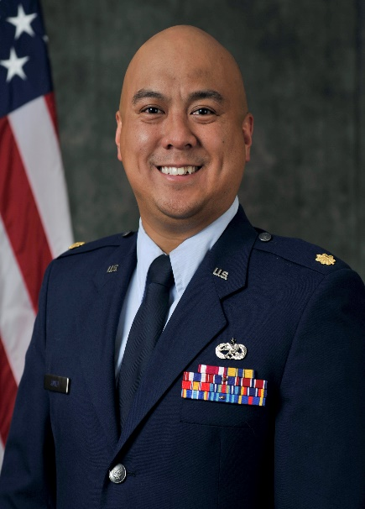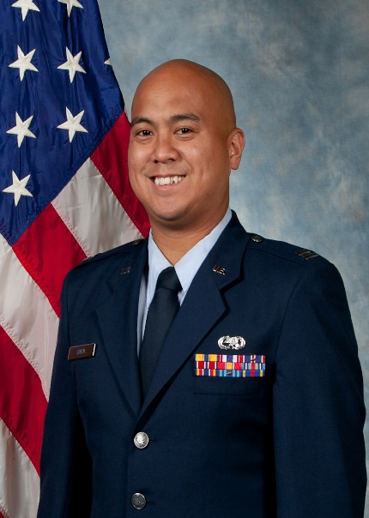**MAJOR R. CHRISTOPHER SMITH**

Major R. Christopher Smith is the Commander at the 36th Maintenance Squadron, Andersen Air Force Base Guam. Major Smith leads 120 assigned and up to 180 deployed active duty, reserve component and contractor personnel across eleven Air Force Specialties. He is responsible for en-route, intermediate and off-equipment maintenance in support of ISR, Strike, Fighter, Mobility, and Transient aircraft. Additionally, he oversees the readiness of Pacific Air Forces’ largest Aerospace Ground Equipment War Reserve Materiel fleet as well as the planning, reception, and employment of back-shop maintenance personnel during Indo-Pacific Command exercises and operations for regional and global events.

Major Smith grew up in Vincennes, Indiana and a 2009 graduate of the United States Air Force Academy, earning a Bachelor’s of Science in Social Science and a second lieutenant commission. After graduation, Major Smith’s next assignments at Travis, Tinker, Creech and Maxwell AFBs were for various maintenance, logistic, and student positions within multiple squadrons and various Wing levels. During his career, he deployed to Al Dahfra Air Base, UAE and AFCENT A4 Rear, directly supporting Operations ENDURING FREEDOM, IRAQI FREEDOM, ODYSSEY DAWN, NEW DAWN, INHERENT RESOLVE and FREEDOM’S SENTINAL.

**EDUCATION**

|  |  |
| --- | --- |
| 2009 | Bachelor of Science in Social Science, United States Air Force Academy, Colorado Springs, CO |
| 2009 | Air and Space Basic Course, Maxwell Air Force Base, AL |
| 2010 | Aircraft Maintenance Officer Course, Sheppard AFB, TX |
| 2010 | Jet Engine Mishap Investigation Course, Sheppard AFB, TX |
| 2013 | Squadron Officer School (in Residence), Maxwell Air Force Base, AL |
| 2014 | Master of Arts in Teaching, Kaplan University |
| 2015 | Maintenance Officer Intermediate Course, Sheppard AFB, TX |
| 2020 | AFCOMAC Senior Officer Orientation Course, Beale AFB, CA |
| 2021 | Air Command and Staff College (in Correspondence), Maxwell Air Force Base, AL |
| 2023 | Master of Science in Military Leadership, ACSC/Air University, Maxwell Air Force Base, AL |
| 2024 | Leadership Development Course for Squadron Command, Maxwell Air Force Base, AL |

**ASSIGNMENTS**

|  |  |
| --- | --- |
| July 2009 – October 2010 | ASSISTANT AMU OIC, 60th Air Mobility Wing, 660th Aircraft Maintenance Squadron, Travis Air Force Base, CA. |
| October 2010 – January 2011 | SUPPORT FLT COMMANDER, 60th Air Mobility Wing, 660th Aircraft Maintenance Squadron, Travis Air Force Base, CA. |
| January 2011 – May 2011 | EXPEDITIONARY ASSISTANT AMU OIC, 380th Expeditionary Wing, 380th Aircraft Maintenance Squadron, Al Dhafra AB, UAE |
| May 2011 – March 2012 | GLOBAL SUPPORT FLT COMMANDER, 615th Contingency Response Wing, 573rd Global Support Squadron, Travis Air Force Base, CA. |
| March 2012 – May 2012 | ASSISTNAT CHIEF, WING TRAINING, 615th Contingency Response Wing, 573rd Global Support Squadron, Travis Air Force Base, CA. |
| May 2012 – January 2013 | MAINTENANCE FLT COMMANDER, 621st West Contingency Response Wing, 571 Global Mobility Squadron, Travis Air Force Base, CA. |
| January 2013 – August 2013 | SQ EXECUTIVE OFFICER, 621st West Contingency Response Wing, 571 Global Mobility Squadron, Travis Air Force Base, CA. |
| August 2013 – April 2016 | RED AMU OIC, 552nd Air Control Wing, 552nd Aircraft Maintenance Squadron, Tinker Air Force Base, OK |
| July 2014 – February 2015 | SENTRY AMU OIC, 380th Expeditionary Wing, 380th Aircraft Maintenance Squadron, Al Dhafra AB, UAE |
| April 2016 – February 2017 | MAINTENANCE OPERATIONS OFFICER, 552d Maintenance Squadron, 552d Air Control Wing, Tinker AFB, OK. |
| February 2017 – September 2017 | MAINTENANCE OPERATIONS OFFICER, 552d Aircraft Maintenance Squadron, 552d Air Control Wing, Tinker AFB, OK. |
| September 2017 – May 2019 | MAINTENANCE OPERATIONS OFFICER, 432d Aircraft Maintenance Squadron, 432d Wing, Creech AFB, NV |
| May 2019 – March 2021 | MAINTENANCE OPERATIONS OFFICER, 432d Maintenance Group, 30th Reconnaissance Squadron, 432d Wing, Creech AFB, NV |
| January 2020 – July 2020 | DEPUTY CHIEF, LOGISTICS READINESS CELL, AFCENT A4, AFCENT Headquarters Shaw AFB, SC |
| March 2021 – July 2022 | INSPECTOR GENERAL DIRECTOR OF EXERCISES, 432d Wing, Creech AFB, NV |
| July 2022 – June 2023 | IDE STUDENT, 38 STUS, Air Command and Staff College (ACSC), Maxwell AFB, AL |
| June 2023 – May 2024 | DIRECTOR OF OPERATIONS AND MAINTNEANCE, 4th Reconnaissance Squadron, 319th Reconnaissance Wing, Andersen AFB |
| May 2024 - PRESENT | COMMANDER, 36thh Maintenance Squadron, Andersen AFB, Guam |

**MAJOR AWARDS AND DECORATIONS**

|  |
| --- |
| Meritorious Service Medal with Second Oak Leaf Cluster |
| Air Force and Space Commendation Medal |
| Meritorious Unit Award with First Oak Leaf Cluster |
| Air and Space Outstanding Unit Award with Second Oak Leaf Cluster |
| Air and Space Organizational Excellence Award |
| National Defense Service Medal |
| Global War on Terrorism Expeditionary Medal |
| Global War on Terrorism Service Medal |
| Air Force Expeditionary Service Ribbon |
| Air Force Longevity Service with Third Oak Leaf Cluster |
| Air Force Training Ribbon |

**EFFECTIVE DATES OF PROMOTION**

|  |  |
| --- | --- |
| Second Lieutenant | 27 May 2009 |
| First Lieutenant | 27 May 2011 |
| Captain | 27 May 2013 |
| Major | 1 Feb 2019 |

(Current as of March 2024)